About Uhay Festival
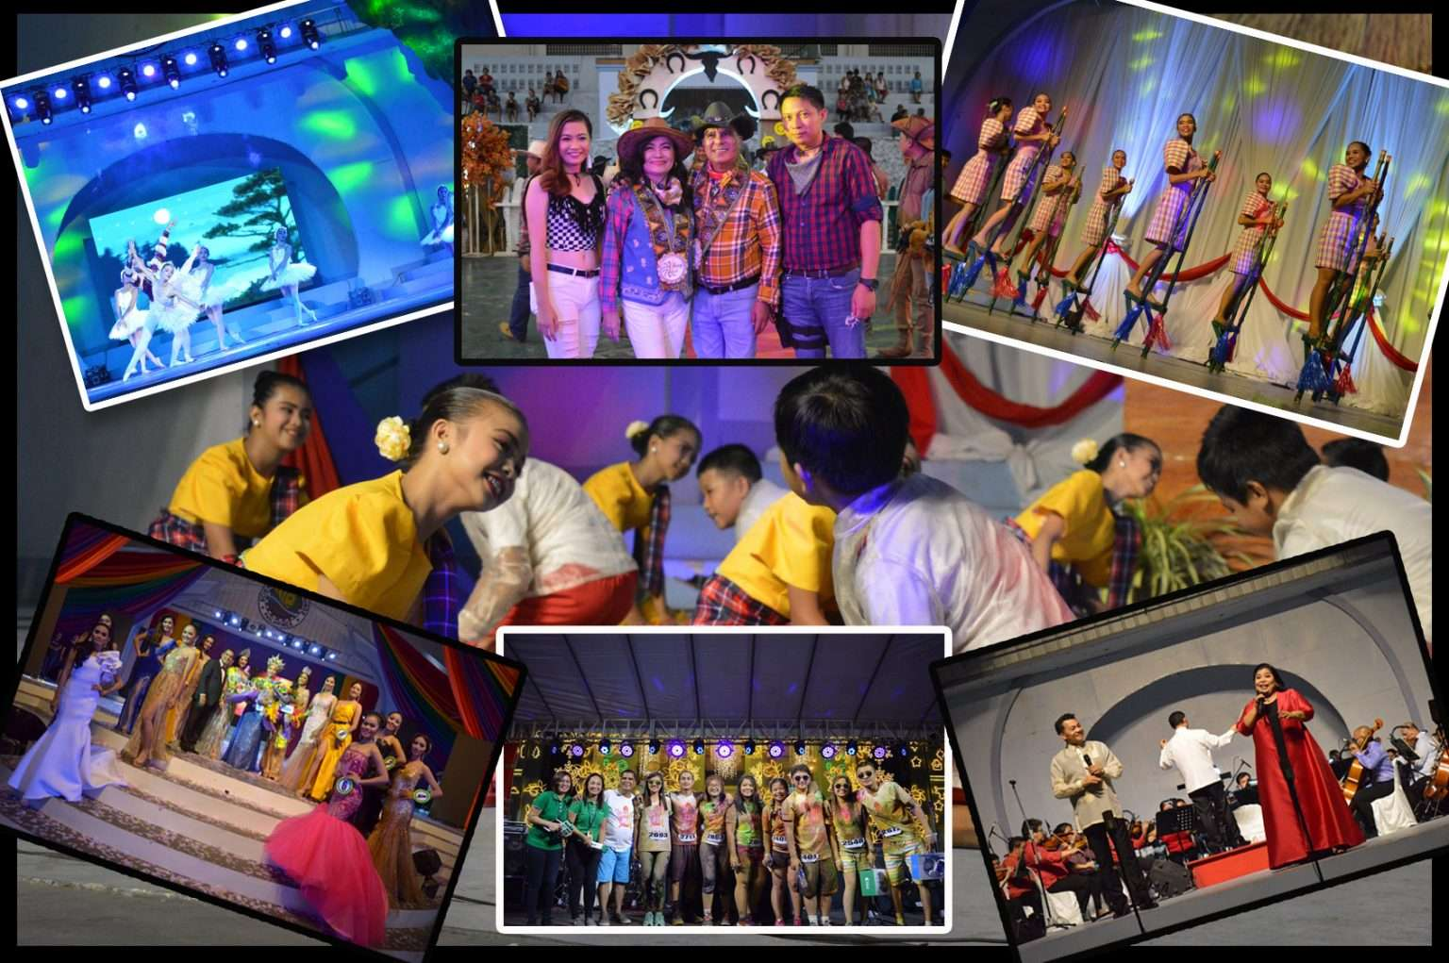
Nueva Ecija is considered as the ‘Rice Granary of the Philippines’ and known to have the biggest supply of rice grains and by-products. The Science City of Muñoz is a 4th class city in the province, and the only Science City in the Philippines. Moreover, it was one of the two Science Cities in the world apart from Tsukuba Science City in Japan. Through continuous progress and advancement of the city as an agricultural state, the locality captured the idea of bringing yearly celebration.
In that sense, “Uhay Festival” was formerly released and the City Mayor, Hon. Nestor L. Alvarez, Ph.D, unveils the seal on the 9th day of December 2013 as the city celebrates its 13th Charter Anniversary. It is the same day whereas it was declared as the Science City in year 2000. From the span of December 9 until January 20, the Local Government Unit (LGU) of Science City of Muñoz has been organizing different programs and activities for the citizens in collaboration with different government and non-government agencies. Part of its celebration is the Founding Anniversary of Muñoz in January 1, 1913. On the 20th day of January, Roman Catholics celebrate the Feast of Saint Sebastian the Martyr, which is also an indication of the last day of the festival.
Uhay Festival denotes the ‘Ani ng Sining at Agham,’ which can be translated as ‘Harvest of Arts and Science.’ This signifies a harvest event or gathering for the progressive implementation of cultural practices as it is celebrated with various programs. It is an occasion that also highlights the excellence and innovation of this agricultural state. This also tends to bring enjoyment to people and to showcase the talents of the generation through the competitions being held and the performing arts. In other words, this harvest event is a big event that is comprised of many other events, which is a way of celebrating and giving back to the people or residents of Science City of Muñoz. There were also events that bring appreciation and recognition to employees and other active organizations within the city that bestow their service in general and taking active part for the development of the city.
Every year is a memorable year. Celebrating this kind of events not only creates impact for the society but also leaving a legacy for the next generation upon imparting cultural practices. Aside from different cultural activities, it also provides services to humanity and opening windows of opportunities for people to take active part in the society.

